A

Project Report

on

**ExamEra- A platform for Online Examination using Springboot and Angular**

By

Divya Prakash Mishra (1813310062)

Ashif Khan (1813310040)

Ayush Verma (1813310049)

Chandra Bhushan Mishra (1813310052)

Under the Supervision of

Ms. Areeba Kazim

(Asst. Professor CSE)

Submitted to the department of Computer Science and Engineering

For the partial fulfillment of the requirements

for award of Bachelor of Technology

in

Computer Science and Engineering



**Noida Institute of Engineering & Technology Gr. Noida**

**Dr. A.P.J. Abdul Kalam Technical University, Lucknow, Uttar Pradesh, India**

**May, 2021-2022**

**CERTIFICATE**

### This is to certify that the Project report entitled “ExamEra – A Platform for online examination using SpringBoot and Angular” is a record of the work done by the following students:

**Student Name Roll No.**

### Divya Prakash Mishra 1813310062

### Ashif Khan 1813310040

### Ayush Verma 1813310049

Chandra Bhushan Mishra 1813310052

### This work is done under my supervision and guidance during the academic year of 2021-22. This report is submitted to the Noida Institute of Engineering & Technology, Greater Noida for partial fulfillment for the degree of B.TECH. (Computer Science and Engineering) of Dr A P J Abdul Kalam Technical University,Lucknow, Uttar Pradesh, India.

I wish them all the best for all the endeavors.

Signature of Guide:

Ms. Areeba Kazim

Assistant Professor

**ACKNOWLEDGEMENT**

I would like to place on record our deep sense of gratitude to **Ms. Areeba Kazim, Assistant Professor , Department of Computer Science and Engineering, Noida Institute of Engineering & Technology**, Greater Noida, Gautam Budha Nagar, Uttar Pradesh, India For her generous guidance, help and useful suggestions.

I express our sincere gratitude to **Prof. Chandra Shekhar Yadav , HOD CSE**, Noida Institute of Engineering & Technology, Greater Noida for his stimulating guidance, continuous encouragement and supervision throughout the course of present work.

**Date:**  **Student Name:**

Divya Prakash Mishra

Ashif Khan

Ayush Verma

Chandra Bhushan Mishra

**ABSTRACT**

The traditional method of Examinations is often characterized as leak of test questions, person errors during marking and recording of points. The necessity for the use of computers, especially in all aspects of human life and activity, has necessitated technological advancements in the field of computer science.

As a result, this project, the Web-based Examination System (Exam Era), sprang from a desire to address widespread issues with the current (paper-based) evaluation system by giving free e-assessment to the entire campus.

The program is built using a combination of HTML, CSS, Angular, TypeScript, Spring Boot, Hibernate, SQL, MySQL can reduce part of the workload in assessment, grading, and review part of the inspectors. As a consequence, the technology permits test results to be released in record time and without mistake. Exam Era Web Application can be an effective solution for mass education by exploring and providing many novel features that are not available on paper systems, such as real-time data collection, management, and analysis, distribution, and collaborative assessment, all of which are aimed at improving primary education.

|  |  |  |  |  |
| --- | --- | --- | --- | --- |
| **TABLE OF CONTENTS** | | | | |
|  | |  | | **Page No.** |
| **Certificate** | |  | | 2 |
| **Acknowledgement** | |  | | 3 |
| **Abstracts** | |  | | 4 |
| **Table of Contents**  **List of Figures** | |  | | 5-6  7-8 |
| **CHAPTER 1** | | **INTRODUCTION** | | **9-11** |
|  | | * 1. Problem Statement   2. Proposed System and its advantages | | 9  9 |
|  | | 1.3 Project Scope | | 10 |
|  | | 1.4 User Characteristics | | 10 |
|  | | 1.5 Project Modules | | 10-11 |
| CHAPTER 2 | | **DESIGN** | | **12-18** |
|  | | 2.1 Flow Chart | | 12 |
|  | | 2.2 Use Case Diagram | | 13-14 |
|  | | 2.3 ER Diagram | | 15-17 |
|  | | 2.4 Architecture | | 18 |
| **CHAPTER 3**  **CHAPTER 4** | | **LITERATURE SURVEY**  **PROPOSED METHODOLOGY**  4.1 Agile Methodology  4.1.1 Planning  4.1.2 Designing  4.1.3 Development Stage  4.1.4 Testing  41.5 Deployment and Maintenance  4.2 Principle of Agile Manifesto | | **19-22**  **23-27**  24-26  24  24  25  25  26  26-27 |
| **CHAPTER 5** | | **ANGULAR** | | **28-30** |
|  | | 5.1 Introduction | | 28 |
|  | | 5.2 Material UI | | 29 |
|  | | * 1. TypeScript   5.4 SCSS  5.5 Angular CLI  5.6 Angular NPM and NG | | 29  29  29  30 |
| **CHAPTER 6** | | **SPRING BOOT** | | **31-33** |
|  | | 6.1 Introduction | | 31 |
|  | | 6.2 Spring Boot JPA | | 32 |
|  | | 6.3 MySQL | | 32 |
|  | | 6.4 JDBC/H2 Database  6.5 Hibernate  6.6 JWT Security | | 32  33  33 |
| **CHAPTER 7** | | **REQUIREMENTS AND PROJECT PROTOCOL** | | **34** |
|  | | 7.1 Software Requirements | | 34 |
|  | | 7.2 Hardware Requirements | | 34 |
| **CHAPTER 8**  **CHAPTER 9**    **CHAPTER 10** | | **SOFTWARE SCREENSHOTS**  **CONCLUSION**  **REFERENCES** | | **35-46**  **47-48**  **49-50** |
|  | |  | |  |
|  | |  | |  |
|  | |  | |  |
| **LIST OF FIGURES** | | | | |
| **Figure No.** | **Figure Name** | | **Page No** | |
| Figure 2.1 | Flow Chart | | 12 | |
| Figure 2.2 | User case diagram | | 13 | |
| Figure 2.3 | ER Diagram based on Entity | | 15 | |
| Figure 2.4  Figure 2.5  Figure 4.1  Figure 4.2 | ER Diagram based on Database  Architecture  Traditional vs Agile Method  Agile Methodology | | 16  18  23  24 | |
| Figure 8.1 | Login Page | | 35 | |
| Figure 8.2 | Signup page | | 36 | |
| Figure 8.3 | Admin Home Initial | | 36 | |
| Figure 8.4 | Admin Profile Page | | 37 | |
| Figure 8.5 | Admin Category | | 37 | |
| Figure 8.6 | Admin Add Category | | 38 | |
| Figure 8.7 | Admin Quizes Initial | | 38 | |
| Figure 8.8 | Admin Add Quizes | | 39 | |
| Figure 8.9 | Admin Quiz added Successfully | | 39 | |
| Figure 8.10 | Admin All Categories | | 40 | |
| Figure 8.11 | Admin All Quizes | | 40 | |
| Figure 8.12 | Admin Add Questions | | 41 | |
| Figure 8.13 | Admin Review Questions | | 42 | |
| Figure 8.14 | Student Home Page | | 43 | |
| Figure 8.15 | Student Instructions Page | | 43 | |
| Figure 8.16 | Student Before Starting Quiz | | 44 | |
| Figure 8.17 | Student Test Screen | | 44 | |
| Figure 8.18 | Student Before Submitting Quiz | | 45 | |
| Figure 8.19 | Student Result Screen | | 45 | |
|  |  | |  | |
| Figure 8.20 | Admin Home Page with all result | | 46 | |

**CHAPTER-1**

**INTRODUCTION**

* 1. **PROBLEM STATEMENT**

Currently, any objective examination conducted by instructors must be checked. Answer sheets must be completed manually, which is inconvenient, and results must be generated manually, which may lead to mistakes.

Students of schools, College and Institutions are helped by Online Examinations as they offer a quick and easy way to appear for the exams. They also provides the results as soon as after the exam ends. Students must provide valid credentials to appear in the tests. This test has multiple choice questions with a sufficient number of alternatives. The number of alternatives is unrestricted, and it can be randomised. This test project has a time constraint for completing the exam. Following the conclusion of the exam, the user can review their results.

**1.2 PROPOSED SYSTEM AND ITS ADVANTAGES**

This online program is designed to overcome the barriers of the existing hands-on system. We have a program of manual testing for most colleges and have identified the possibility of default. The proposed system has many advantages. Students from different parts of the country can register very easily. The new system is customized. It is a maze in such a way that all new users understand all the options in it very easily. Made with quick and easy reference. Access to all essential items is not always locked and can be easily unlocked during an emergency. The advantages of the proposed system are that security is maintained in the new system. The securities of all important data are kept confidential. As it is easy to understand and easy to use, quick access can be made to this program.

1. Provides a complete online web-based solution, which includes student enrollment, exam testing, and record keeping.
2. Completely web-based management, the administrator can manage test bank and queries using the web interface.
3. The local boundary means nothing.
4. The student can offer 24X7 tests from anywhere in the world.
5. 100% accuracy in calculating results.
6. Random set of questions.

**1.3 PROJECT SCOPE**

* The Online Examination program is designed for Educational Institutions (such as schools, colleges, universities, Training Institutions).
* Can be used anywhere at any time as it is a web-based application. Reduces students' time doing personal tests.
* This system will provide better security and transparency in testing.
* The system handles all operations, and generates reports as soon as the test is completed, including name, mark, time spent solving the test,
* Allows learners to test correct answers after the test.
* The type of questions are just a lot of choices either true or false

**1.4 USER CHARACTERSTICS**

There are 3 types of users in proposed System

* **Student:** The student will log in to the system and complete his or her exam. They can also check their previous exam results and personal information. The student will receive the results as soon as the test is over.
* **Examiner:** Each course's examiner will prepare questions and alternatives, which will be placed into the programme. Student certificates created by the system will be approved by examiners.
* **Administrator:** The administrator is the system's primary user, and he has total power over the website.

**1.5 PROJECT MODULES**

* **Accounts Module:** The module stores individual student information and provides. student information storage area and students can change their passwords in this module if necessary.
* **Examination Module:** In this module students can take tests and submit answers. The system can create tests automatically by selecting questions on the website. Provides limited time to answer questions. When the student starts the test the timer will automatically start and show the student how much time is left. After testing this module will be disabled automatically and Results can be viewed immediately after Posting.
* **Dashboard Module:** Only the director and inspector can access this module, where the administrator or inspector can view student details, mark report, test report, etc. It has a place to add student information, view Student List and Edit student information and Also the administrator can manage users. details, course and course details.
* **Question Bank Module:** The inquiry bank will have a plan to add, modify and delete questions in the article. Here the Examiner can upload questions and set measurement schemes and the duration of the test Questions have different attributes such as title, title, marks, questionnaire, options and answer. The question can be text or a picture.
* **Results Module:** Students and examiners will immediately get their results. Results can also be printed as soon as the test finishes.

**CHAPTER-2**

**DESIGN**

Designing of this application is mainly represented using

Four types of diagrams-

• Flow chart

• Use Case Diagram

• ER Diagram

**2.1 FLOW CHART**

Flow chart is the initial step about the application design.

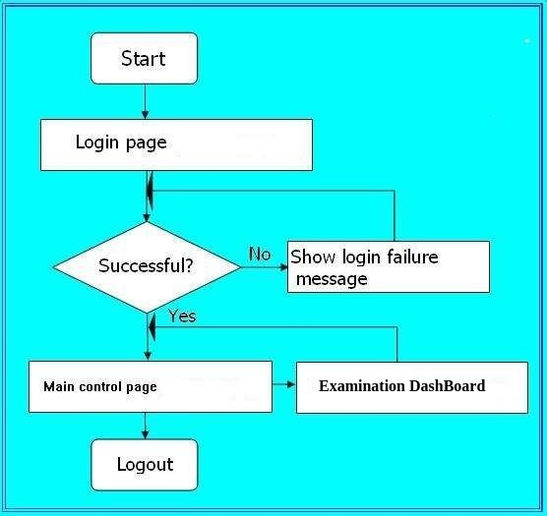

Figure-2.1 (Flowchart)

**2.2 USE CASE DIAGRAM**

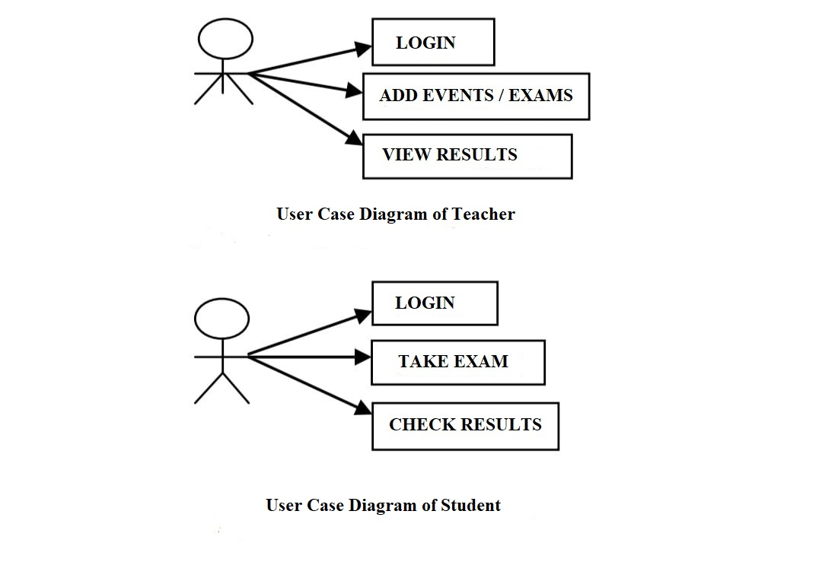

Figure- 2.2(Use case Diagram)

### A simple user interface diagram represents the user interaction with a system that shows the relationship between the user and the different operating conditions in which the user is involved. The application case diagram can identify different types of system users. System modeling is a very important factor in capturing dynamic behavior. To elaborate in more detail, dynamic behavior means the behavior of system when activated. So static behavior alone is not enough to make a model a system instead of dynamic behavior is more important than static behavior. In the UML there are five diagrams available to show the dynamic environment and the usage diagram is one of them. Now as we have to discuss that the graph of use case is naturally strong it should be certain internal or external factors to make communication.

### These inner and outer ones are known as actors. Therefore, the use case drawings contain the characters, the use cases and their relationships. The diagram is used to create a sub-system / system model of the application. One-use case diagram captures system performance. Therefore, modeling all the system numbers of the drawings of the application cases used.

**Purpose:-**

Because the other four diagrams (function, sequence, collaboration and Statechart) also have the same purpose. Therefore, we will investigate a specific purpose that will distinguish it from the other four drawings. Now as we have to discuss that the use case diagram is inherently powerful there should be internal or external factors to make the connection. These inner and outer ones are known as actors. Therefore, the use case drawings contain the characters, the use cases and their relationships. The usage case diagram does not show usage details: it only summarizes the specific relationships between application situations, characters, and programs. The diagram does not show how the steps are performed to achieve the objectives of each use case. You may be able to explain such details in other drawings and documents, which you can link to each use case.

**2.3 ER DIAGRAM**

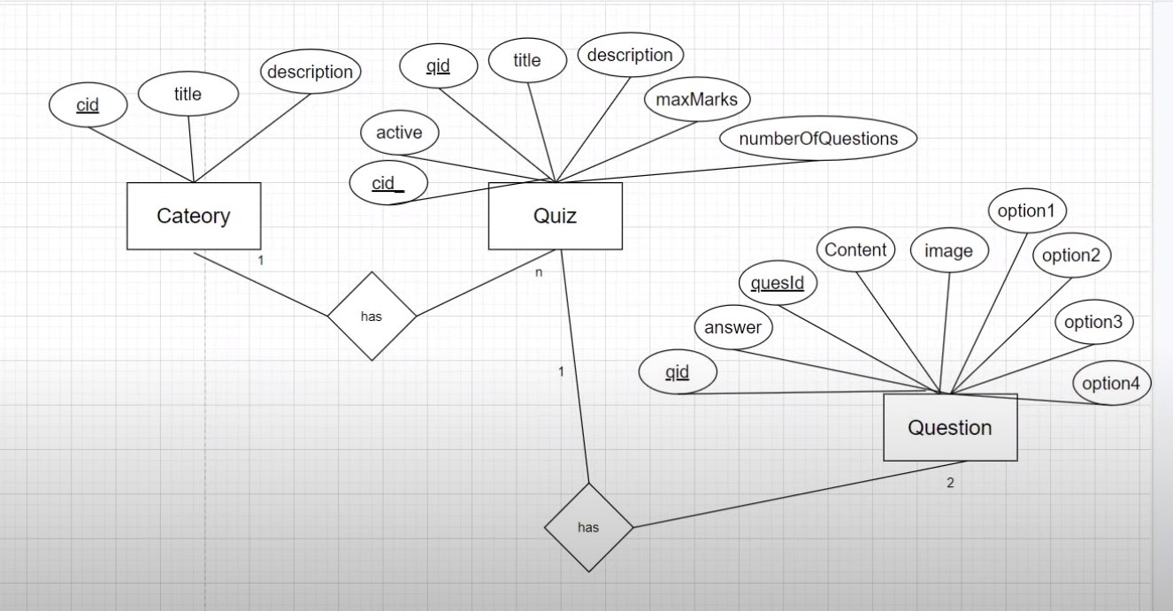

Figure- 2.3(ER Diagram based on Entity)

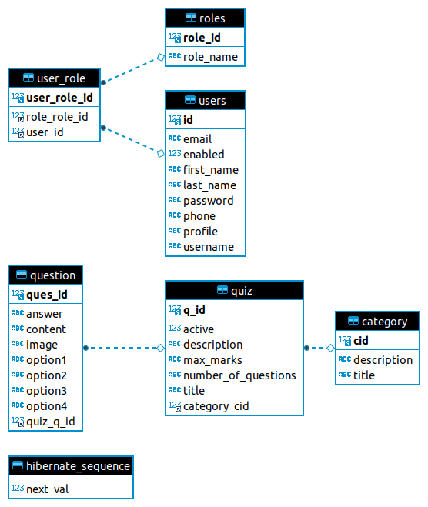

Figure- 2.4(ER Diagram based on Database)

### A entity relationship model is a graphic representation of businesses and their relationships with others, often used in computer calculations with respect to data processing within information or information systems.

### The Entity Relationship (ER) diagram is a special diagram showing the relationships between businesses on a website.

### Demonstrates the logical flow of the system. In the program, define input (source), output (location), website (data stores) and processes (data flow) all in a format that meets the user's requirement. When the analyst prepares for the creation of a logical system, he defines user needs at the data level that determines the probability of the entry and exit of information into the system and the required data resources. Logical design also specifies input forms and screen layouts. Tasks that follow the correct structure are the procedures followed in body composition e.g. production programs, software, file, and operating system. Design Details instructs the user about what the system should do.

### To construct ER-diagrams, we use:

### Data models are tools used in analysis to define data needs and system assumptions from a top-down perspective. They also set the stage for later information design in the SDLC.

### There are three basic elements in ER models:

### 1. Entities are the real world objects about which we look for information.

### 2. Attributes are the properties that are associated with the entities.

### 3. The structure required to collect information from multiple entities is presented by the relationship between them.

**2.4 ARCHITECTURE**

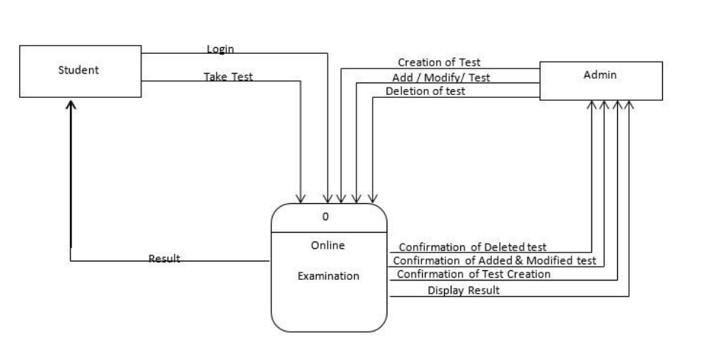

Figure- 2.5(Architecture)

The project mainly comprise of two views-

1. Student View/User View
2. Teacher View/Admin View

The functionalities given to each depends on the authorization given to them, A teacher can login and access the functions like Creation of test, Add/Modification of exiting test and Deletion of test as well.

The Students View functionalities are limited to Login and Take test, upon successful completion of the assigned test they will see the immediate result on their Dashboard.

For the time bound, a timer is also added and the teacher has the authority to set the time constraint for each question. Once the allotted time will be over the test will be auto submitted and the result will be displayed immediately.

**CHAPTER-3**

**LITERATURE SURVEY**

**TRADITIONAL VERSUS ONLINE TEST**

Tests are used in educational institutions to track student academic progress, analyse,

compare, and assess the effectiveness of teaching techniques, and serve as the foundation

for student guidance and counselling, award selection and recruiting, and certification

grading.

Another possible aim of the exam in the case of an educational system is to determine if

the student has met the educational goal. The results of such an evaluation may assist

teachers in analysing difficulties with their teaching method(s) and better understanding

the learner's strengths and limitations in a certain subject. The test can be used to fine-tune

the teaching environment or method based on the results of the analysis in order to

improve the effectiveness of the teacher's teaching .There are currently two methods for

conducting examination tests: I the traditional method of using paper and pencil tests,

which includes the creation of assessment materials, grading of test papers for students,

and analysis of student responses to each test item, which is tedious; and (ii) ComputerBased

Testing, also known as electronic testing, which allows test activities to be

performed in a different electronic field / environment. Essentially, the e-Examination

system entails administering exams utilising a variety of electronic devices (cell phones,

PCs, etc.) that are connected to the test system through the Internet or Intranet. Because

the process is automated, managing, grading, and testing reviews takes very little time.

Tests are often used to evaluate a variety of choices.

Examination is defined by Ayo et al. (2007) as a system that involves the execution of

tests on the web or intranet. They've recommended an e-Examination model in Nigeria, in

which all applicants are examined online to eliminate irregularities, as advocated by the

Joint Admissions Matriculation Board (JAMB), the body in charge of all admission

examinations. Covenant University, one of Nigeria's most autonomous universities,

developed and tested this approach. Their findings suggest that the software has the

ability to solve some of the issues that traditional testing techniques have, such as

impersonation and other forms of test failures.

Gardner, etc. al. (2002) in their work created a computer-based learning program, called

CECIL, which incorporates the exciting task of 'self-assessment' to improve student

learning achievement. The 'self-assessment' function is equipped with a pool of objects

and teachers can easily manage and build tests online. They also point out that material

ponds have the benefit of allowing "teachers to include vast material banks (material

ponds) from textbook publishers and load these questions with a lot of hands-on work."

Gardner et al. (2002) also noted that teachers who manage and create online exams have

the benefit of assisting students in assessing their grasp of learning materials at any time.

Management is the provision of test materials and random selection, providing test

passwords for test takers to use the Web site and collecting and recording test school data.

The evaluation focuses on analyzing the collected / analyzed data for the test and

compiling a mathematical report.

Zhenming, et al. (2003) suggested a computer science exam software and a web-based

competency test. Rashad et al (2010) suggested a web-based online testing method in

another study effort. On student tests, the system runs tests and grades them

automatically. It may be used to ask a variety of queries. It was always suited for local

and remote testing and was utilised online. This programme can assist instructors,

teachers, teachers, and anyone who are interested in taking new tests or planning old ones,

as well as students who take part in the exams. A range of open-source technologies are

used to construct the system. This software makes use of AJAX, PHP, HTML, and a

MySQL database. The automatic grading module may be adjusted to accommodate

various examinations and question kinds. The software was put through its paces at

Mansoura University's Quality Assurance Department. Tests have shown that adopting

this form of web-based evaluation method for pupils with large enrolment is legitimate.

**ExamEra -A PLATFORM FOR ONLINE EXAMINATION USING SPRING BOOT AND ANGULAR**

At many Indian institutions of junior and higher learning, exam writing and the process of issuing results are fraught with problems that lead to the inability to produce results on time, the inability of some students to obtain their results, and a host of incomplete results. These problems can be reduced by using an electronic medium. ExamEra , as used in this paper, refers to a process that involves the administration of tests on the web or intranet using a computer program. Recently, with the advent of internet technology and databases, CBT that was once exclusively held on personal computers (PCs) or local networks (LANs), has now gradually been developed to work online using browsers as a visual connector, for testing, that users can use from all around the world.

It is not enough to focus on the skills required of distant students’ education but to give them equal performance after testing without collision. As a result, the enhanced WES is able to resolve issues problems with traditional assessment methods and equally promotes grade education.

When the online teaching method is used to acquire skills in higher education, the application can be used for effective testing regardless of location explores the whole world.

It is possible for this program to set a test time without compromising quality and integrity of the test. The system has the ability to reduce incorrect testing as applicants are properly verified online, in real time before taking the test and the accuracy of the result can also be improved from candidates can access immediate test results.

Therefore, in the current era of distance education resulting from the adoption of ICT, Examination has the advantage of being easy to manage, the ability to provide applicants.

quick results, easy verification, no paperwork and long involvement in marking

test papers are often erroneous and misguided texts due to the large volume of texts to be marked and accessed. System and saves teachers from suffering and boring scheduling

evaluates the achievement of outcomes thereby promoting an effective system of primary education.

If the ExamEra Application is fully developed and presented to institutions, that is the case will go a long way in controlling and evaluating fraudulent practices and all fraudulent activities accompanied by a manual examination procedure. However, for the system accepted to a large extent, efforts must be intensified in order to detect its deterioration accounts of IT literacy on the part of students, making the visual interface easier work together. Also, to ensure that the e-examinations system is not strengthened by those may want to engage in any form of test malpractice, user add-on Verified protocols / methods such as biometrics identification would be a good help.

In the future, we aim to address the limitations of the current application by integration

an online collection of results from a variety of tested subjects, including Growing Grade

Point Aggregate (CGPA) and document production (with required security features)

to promote the introduction of primary education.

**CHAPTER-4**

**PROPOSED METHODOLOGY**

Heading towards the agile methodology ExamEra achieved great developmental milestones. Agile is a software development methodology to build a software incrementally using short iterations of 1 to 4 weeks so that the development is aligned with the changing business needs. Instead of a single-pass development of 6 to 18 months where all the requirements and risks are predicted upfront, Agile adopts a process of frequent feedback where a workable product is delivered after 1 to 4 week iteration.

In comparison to traditional way of developing software agile methodology is way more effective and productive.

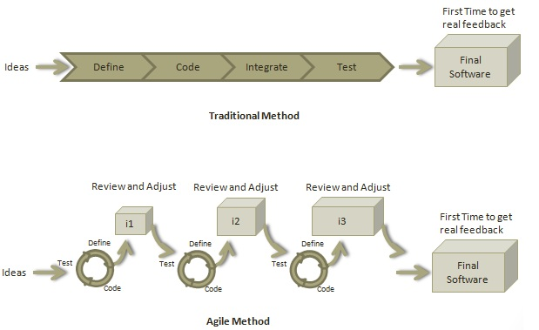

Figure-4.1(Traditional Vs Agile Methodology)

**4.1 AGILE METHODOLOGY**

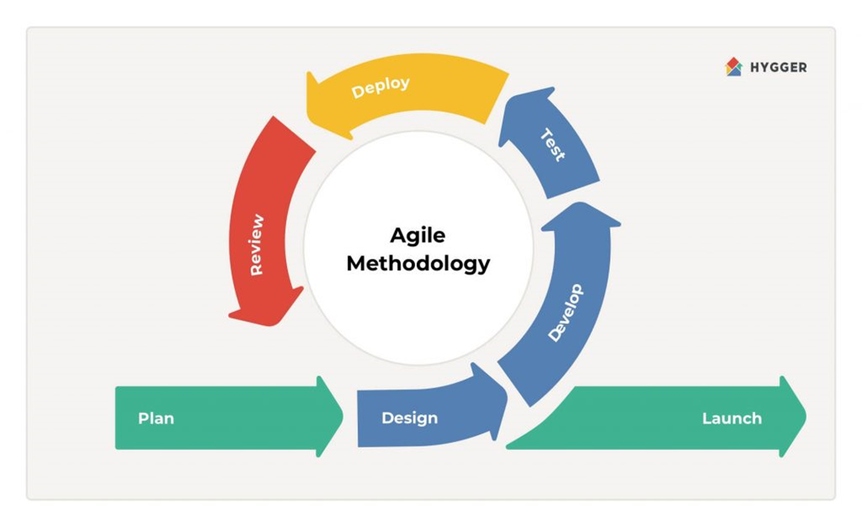

Figure-4.2(Agile Methodology)

**4.1.1 PLANNING**

[Agile planning](https://monday.com/blog/streamline-marketing-ops-agile-marketing/) is a project planning method that estimates work using self-contained work units called *iterations* or *sprints*. Sprints are periods of 1-3 weeks in which a team focuses on a small set of work items as well as [OKRs](https://www.founderjar.com/what-is-okr/), and aims to complete them.

Agile planning also creates a repeatable process that helps teams learn how much they can achieve. This is made easier and more organized with working software that can allow you to easily update and share iterations and move tasks to and from your product backlog. More on this later.

**4.1.2 DESIGNING**

Every feature travels two paths as it's being developed: user experience design and visual design. User experience design employs design thinking to focus on the information architecture and workflows throughout the new feature. Visual design encompasses interaction design and how a feature is styled. Sometimes teams focus too heavily on visual design because it's an emotional part of the product development process. (Plus, it's all shiny and fun and stuff.) But, while important, visual design cannot eclipse good user experience design. Indeed, without good user experience design, even the most stunning visual design won't make users fall in love with the product.

With their highly-tuned empathy for the user's experience, and sixth sense for spotting abnormalities in typography and goofy layouts, designers are an incredibly valuable source of feedback. Make sure they can easily capture screenshots, mark them up, and report defects or suggest improvements Developers and product owners can design too!

**4.1.3 DEVELOPMENT STAGE**

* The development stage is the part where developers actually write code and build the application according to the earlier design documents and outlined specifications.
* This is where [Static Application Security Testing](https://clouddefense.ai/sast-static-application-security-testing) or SAST tools come into play.
* Product program code is built per the design document specifications. In theory, all of the prior planning and outlined should make the actual development phase relatively straightforward.
* Developers will follow any coding guidelines as defined by the organization and utilize different tools such as compilers, debuggers, and interpreters.
* Programming languages can include staples such as JavaScript, python, and more. Developers will choose the right programming code to use based on the project specifications and requirements.

**4.1.4 TESTING**

* Building software is not the end.
* Now it must be tested to make sure that there aren’t any bugs and that the end-user experience will not negatively be affected at any point.
* During the testing stage, developers will go over their software with a fine-tooth comb, noting any bugs or defects that need to be tracked, fixed, and later retested.
* It’s important that the software overall ends up meeting the quality standards that were previously defined in the SRS document.
* Depending on the skill of the developers, the complexity of the software, and the requirements for the end-user, testing can either be an extremely short phase or take a very long time.

**4.1.5 DEPLOYMENT AND MAINTENANCE**

After testing phase software product is all set land into the market and make it available to the end user. The SDLC doesn’t end when software reaches the market. Developers must now move into a maintenance mode and begin practicing any activities required to handle issues reported by end-users.

Furthermore, developers are responsible for implementing any changes that the software might need after deployment.

This can include handling residual bugs that were not able to be patched before launch or resolving new issues that crop up due to user reports. Larger systems may require longer maintenance stages compared to smaller systems.

**4.2 PRINCIPLE OF AGILE MANIFESTO**

* **Customer Satisfaction** − Highest priority is given to satisfy the requirements of customers through early and continuous delivery of valuable software.
* **Welcome Change** − Changes are inevitable during software development. Ever-changing requirements should be welcome, even late in the development phase. Agile processes should work to increase customers' competitive advantage.
* **Deliver a Working Software** − Deliver a working software frequently, ranging from a few weeks to a few months, considering shorter time-scale.
* **Collaboration** − Business people and developers must work together during the entire life of a project.
* **Motivation** − Projects should be built around motivated individuals. Provide an environment to support individual team members and trust them so as to make them feel responsible to get the job done.
* **Face-to-face Conversation** − Face-to-face conversation is the most efficient and effective method of conveying information to and within a development team.
* **Measure the Progress as per the Working Software** − Working software is the key and it should be the primary measure of progress.
* **Maintain Constant Pace** − Agile processes aim towards sustainable development. The business, the developers, and the users should be able to maintain a constant pace with the project.
* **Monitoring** − Pay regular attention to technical excellence and good design to enhance agility.
* **Simplicity** − Keep things simple and use simple terms to measure the work that is not completed.
* **Self-organized Teams** − An agile team should be self-organized and should not depend heavily on other teams because the best architectures, requirements, and designs emerge from self-organized teams.
* **Review the Work Regularly** − Review the work done at regular intervals so that the team can reflect on how to become more effective and adjust its behavior accordingly.

**CHAPTER-5**

**ANGULAR**

**5.1 INTRODUCTION**

Angular is an open-source JavaScript framework developed by Google. It helps you to create single-page applications, one-page web applications that only require HTML, CSS, and JavaScript on the client side. It is based on MVC, pattern and build well structured, easily testable, and maintainable front-end applications.

Angular has changed the way to web development. It does not base on jQuery to perform its operations. Till now you are using ASP.NET, ASP.NET MVC, PHP, 6P, Ruby on Rails for web development but now you can do your complete web development by using most powerful and adaptive JavaScript Framework Angular. There is no doubt, JavaScript frameworks like Angular Ember etc. are the future of web development

Advantages of Angular Includes

* DEVELOP ACROSS ALL PLATFORMS - There is only one way to build applications with Angular and reuse your code and abilities to build apps for any deployment target. For web, mobile web, native mobile and native desktop
* SPEED & PERFORMANCE – Angular archives the maximum speed possible on the Web Platform today, and take it further, via Web Workers and server-side rendering.

Angular puts you in control over scalability. Meet huge data requirements by building data models on RxJS, Immutable.js or another push-model.

* INCREDIBLE TOOLING – Angular build features quickly with simple, declarative templates. Extend the template language with your own components and use a wide array of existing components.

**5.2 MATERIAL UI**

Angular Material is a UI component library for Angular JS developers. Angular Material components help in constructing attractive, consistent, and functional web pages and web applications while adhering to modern web design principles like browser portability, device independence, and graceful degradation. It helps in creating faster, beautiful, and responsive websites. It is inspired by the Google Material Design.

The angular Material style could be a specification for a unified system of visual, motion, and interaction design that adapts across different devices and different screen sizes. It is creating faster, beautiful, and responsive websites.

**5.3 TYPESCRIPT**

**TypeScript** is a programming language developed and maintained by [Microsoft](https://en.wikipedia.org/wiki/Microsoft). It is a strict syntactical [superset](https://en.wikipedia.org/wiki/Superset) of [JavaScript](https://en.wikipedia.org/wiki/JavaScript) and adds optional [static typing](https://en.wikipedia.org/wiki/Static_typing) to the language. TypeScript is designed for the development of large applications and trans compiles to JavaScript.[[4]](https://en.wikipedia.org/wiki/TypeScript#cite_note-4) As TypeScript is a superset of JavaScript, existing JavaScript programs are also valid TypeScript programs.

TypeScript may be used to develop JavaScript applications for both [client-side](https://en.wikipedia.org/wiki/Client-side) and [server-side](https://en.wikipedia.org/wiki/Server-side) execution (as with [Node.js](https://en.wikipedia.org/wiki/Node.js) or [Angular](https://en.wikipedia.org/wiki/Deno_(software))). There are multiple options available for trans compilation. Either the default TypeScript Checker can be used, or the [Babel](https://en.wikipedia.org/wiki/Babel_(transcompiler)) compiler can be invoked to convert TypeScript to JavaScript.

**5.4 SCSS**

**Syntactically Awesome Style Sheet** is the superset of CSS. SCSS is the more advanced version of CSS. SCSS was designed by Hampton Catlin and was developed by Chris Eppstein and Natalie Weizenbaum. Due to its advanced features it is often termed as Sassy CSS. SCSS have file extension of .scss.

SCSS is used in integration with angular to create responsive and beautiful web application.

**5.5 ANGULAR CLI**

**Angular CLI** is a command line interface, thus ‘CLI’, which includes the functionality that Webpack provides. It uses Webpack to include all the packaging, importing, BrowserLink etc., but you do not need to know how Webpack works or how it needs to be configured to run in different environments or on different types of machines. All the Webpack configuration is done completely by CLI and leaves it out of the hands of a developer, unless they choose to adjust the settings themselves.

* 1. **ANGULAR NPM AND NG**

**NPM** is basically a package manager which acts as a dependency provider. If there are many small packages, required to build a large one, NPM is the one hotspot which will provide us with the packages. Angular-CLI is one of those packages. As far as NG is concerned, it is the core module of Angular. Whenever, an application is started,the NG module is loaded by deafult. The module itself contains the essential components for an AngularJS application to function.

The prefix ng stands for "Angular;" all of the built-in directives that ship with Angular use that prefix. Similarly, it is recommended that you do not use the ng prefix on your own directives in order to avoid possible name collisions in future versions of Angular.

**Npm Start** - If we use this cmd, it will run whatever we have defined for the 'start' command of the scripts object in package.json file. And this internally contains ng serve command in it.

**Ng Serve** - It builds the application & starts the web server.And ng serve is the reason behind the auto compilation when changes are made(i.e when saved).It is related with angular cli.

**CHAPTER-6**

**SPRING BOOT**

**6.1 INTRODUCTION**

Spring Boot is an open source, microservice-based Java web framework. The Spring Boot framework creates a fully production-ready environment that is completely configurable using its prebuilt code within its codebase. The microservice architecture provides developers with a fully enclosed application, including embedded application servers.

Spring Boot is just extension of the already existing and expansive Spring frameworks, but it has some specific features that make the application easier for working within the developer ecosystem. That extension includes pre-configurable web starter kits that help facilitate the responsibilities of an application server that are required for other Spring projects.

### Advantages of SpringBoot includes

### STANDALONE APPLICATION - Can simply build the application jar and run the application with no need to customize the deployment.

### EMBEDDED SERVERS - Comes with prebuilt Tomcat, Jetty and Undertow application servers that do not require further installation to use. This also provides faster more efficient deployments resulting to shorting restart times.

### AUTO CONFIGURABLE - Spring and other 3rd party frameworks will be configured automatically.

### PRODUCTION LIKE FEATURES - Health checks, metrics and externalized configurations.

### STARTER DEPENDCIES- This will provide opinionated dependencies designed to simplify the build configuration. This also provides complete build tool flexibility (Maven and Gradle).

**6.2 SPRING BOOT JPA**

### ****Spring Boot JPA**** is a Java specification for managing **relational** data in the Java applications. It allows us to access and persist data between Java object/ class and relational database. JPA follows **Object-Relation Mapping**(ORM). It is a set of interfaces. It also provides a runtime **EntityManager** API for processing queries and transactions on the objects against the database. It uses a platform-independent object-oriented query language JPQL (Java Persistent Query Language).

**6.3 MY SQL**

MySQL, the most popular Open Source SQL database management system, is developed, distributed, and supported by Oracle Corporation.

### The MySQL Database Software is a client/server system that consists of a multithreaded SQL server that supports different back ends, several different client programs and libraries, administrative tools, and a wide range of application programming interfaces (APIs).

**6.4 JDBC/ H2 DATABASE**

### Java Database Connectivity (JDBC) is an application programming interface (API) for the programming language Java, which defines how a client may access a database. It is a Java-based data access technology used for Java database connectivity. It is part of the Java Standard Edition platform, from Oracle Corporation. It provides methods to query and update data in a database, and is oriented toward relational databases. A JDBC-to-ODBC bridge enables connections to any ODBC-accessible data source in the Java virtual machine (JVM) host environment.

### JDBC ('Java Database Connectivity') allows multiple implementations to exist and be used by the same application. The API provides a mechanism for dynamically loading the correct Java packages and registering them with the JDBC Driver Manager. The Driver Manager is used as a connection factory for creating JDBC connections.

### JDBC connections support creating and executing statements. These may be update statements such as SQL's CREATE, INSERT, UPDATE and DELETE, or they may be query statements such as SELECT. Additionally, stored procedures may also be invoked through a JDBC connection.

**6.5 HIBERNATE**

### Hibernate is a Java framework that simplifies the development of Java application to interact with the database. It is an open source, lightweight, ORM (Object Relational Mapping) tool. Hibernate implements the specifications of JPA (Java Persistence API) for data persistence.

### Hibernate framework is open source under the LGPL license and lightweight.The performance of hibernate framework is fast because cache is internally used in hibernate framework. There are two types of cache in hibernate framework first level cache and second level cache. First level cache is enabled by default.

### HQL (Hibernate Query Language) is the object-oriented version of SQL. It generates the database independent queries. So you don't need to write database specific queries. Before Hibernate, if database is changed for the project, we need to change the SQL query as well that leads to the maintenance problem.

### Hibernate framework provides the facility to create the tables of the database automatically. So there is no need to create tables in the database manually.

**6.6 JWT SECURITY**

### JSON Web Token or JWT, as it is more commonly called, is an open Internet standard (RFC 7519) for securely transmitting trusted information between parties in a compact way. The tokens contain claims that are encoded as a JSON object and are digitally signed using a private secret or a public key/private key pair. They are self-contained and verifiable as they are digitally signed. JWT’s can be signed and/or encrypted. The signed tokens verify the integrity of the claims contained in the token, while the encrypted ones hide the claims from other parties.

**CHAPTER-7**

**HARDWARE AND SOFTWARE REQUIREMENTS**

**7.1 SOFTWARE REQUIREMENTS FOR DEVELOPMENT OF PROJECT**

### Microsoft VS code

### Intellij Idea

### My SQL

* DBeaver

### Git

### TypeScript

### Angular

### SpringBoot

### Windows 8 or above/ Linux/ MacOs

**7.2 HARDWARE REQUIREMENTS FOR DEVELOPMENT OF PROJECT**

### RAM 4GB or above (optimal if RAM 8GB or above)

### Hard Disk 1TB or above (can work with 512GB)

### Intel Core i5 or above

### SSD 128GB (optional for better performance)

**CHAPTER-8**

**SOFTWARE SCREEN SHOTS**

1. **LOGIN PAGE**

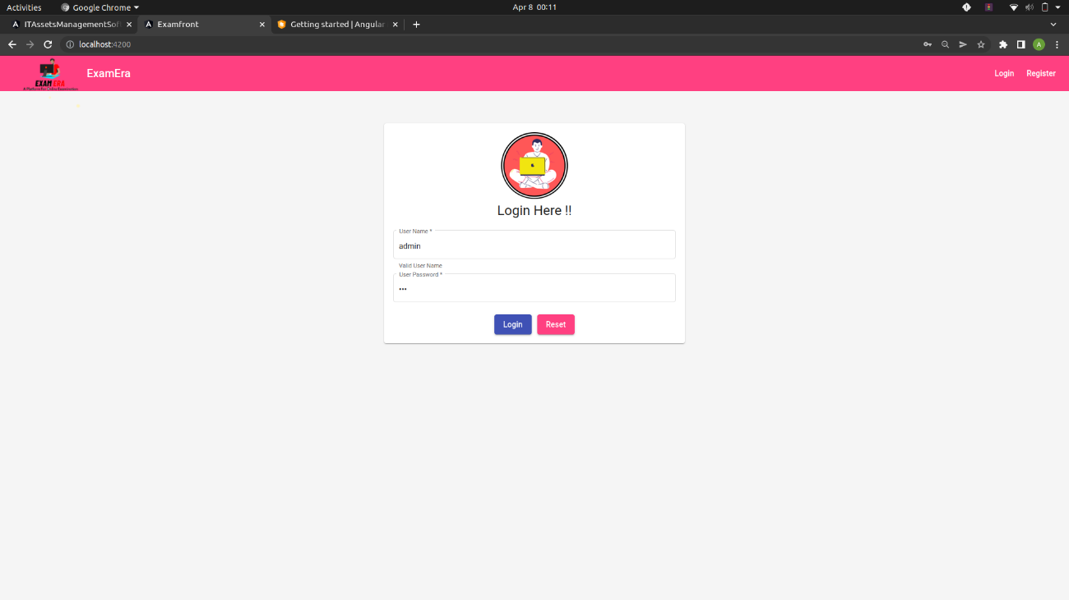

Figure-8.1(Login Page)

This page allows administrator to enter his login credentials to enable him/her create exams, create questions, register students, view scores and then log out and the users to enter into their tests, check their dashboard, take the assigned test and check the results after the successful completion of the test.

1. **SIGNUP PAGE**

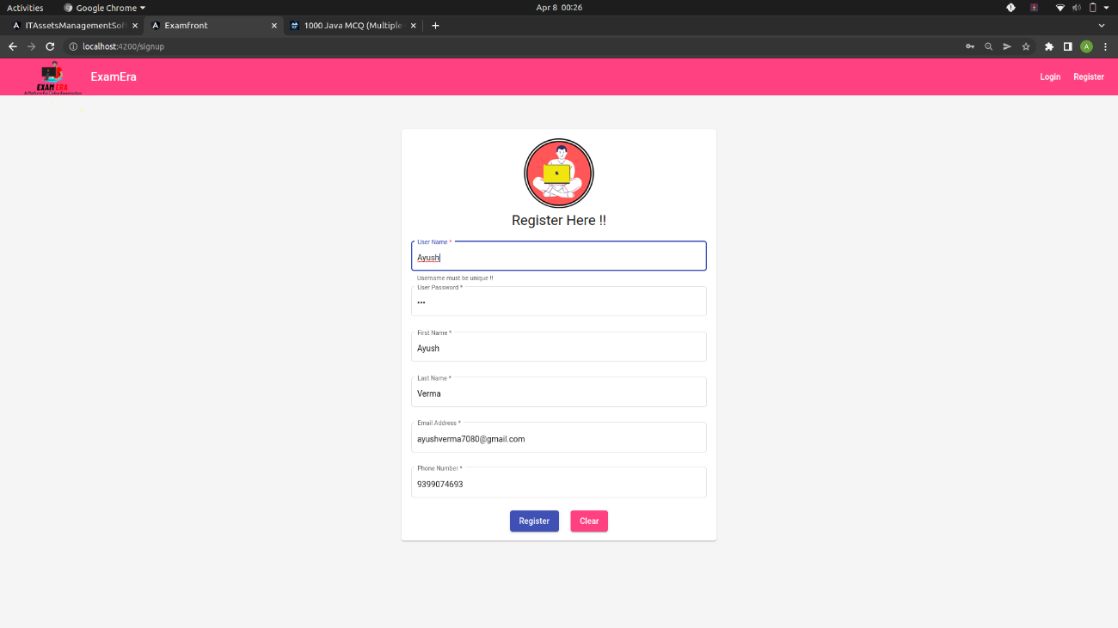

Figure-8.2(SignUp Page)

This page is for the registration of new users it will ask the user to fill in details like User Name, Full Name, Email Id, Password and the Phone number.

1. **ADMIN PANEL PAGE**

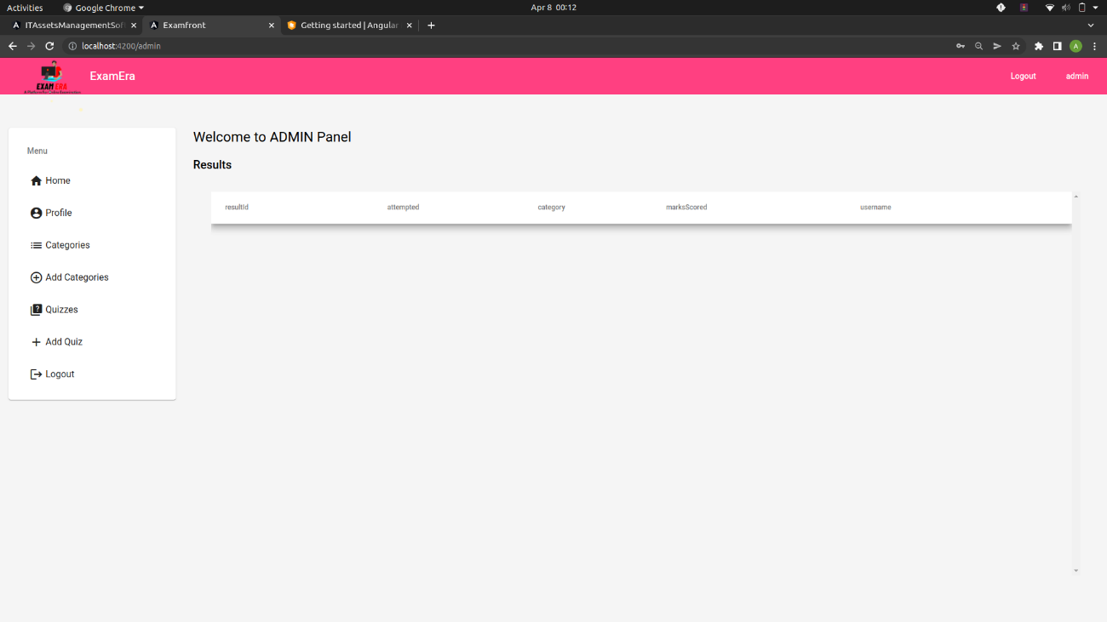

Figure-8.3(Admin home screen Initial)

This page is for the Admin, they can add new categories, Quizzes and can edit the existing Quizzes also.

1. **ADMIN PROFILE PAGE**

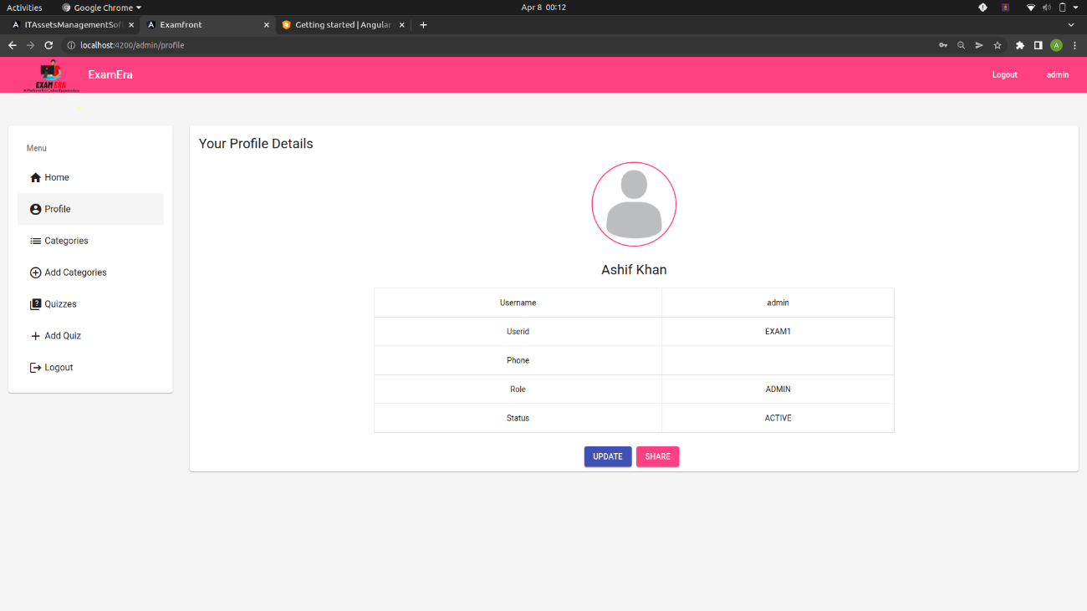

Figure-8.4(Admin Profile Page)

This is the admin profile page for the admins to update the personal details.

1. **ADMIN CATEGORY PAGE**

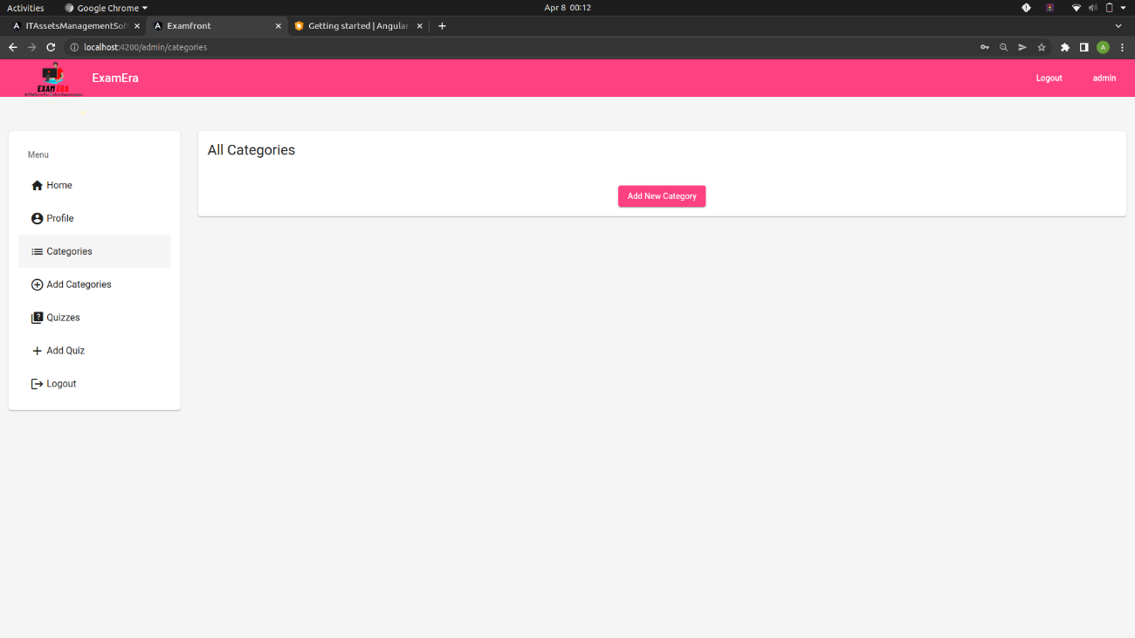

Figure-8.5(Admin Category)

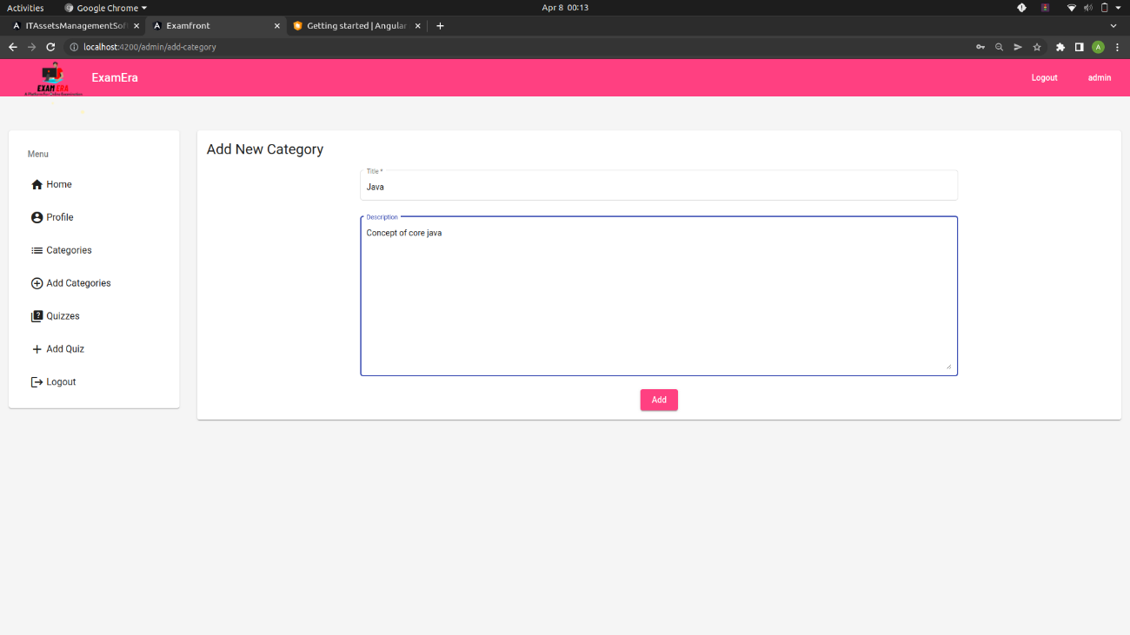

Figure-8.6(Admin Add Category)

1. **ADMIN QUIZZ PAGE**

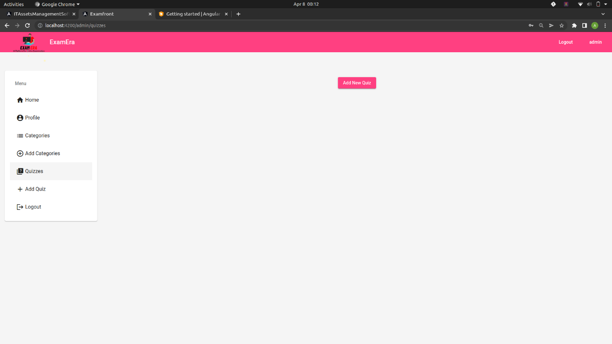

Figure-8.7(Admin Quizes initial)

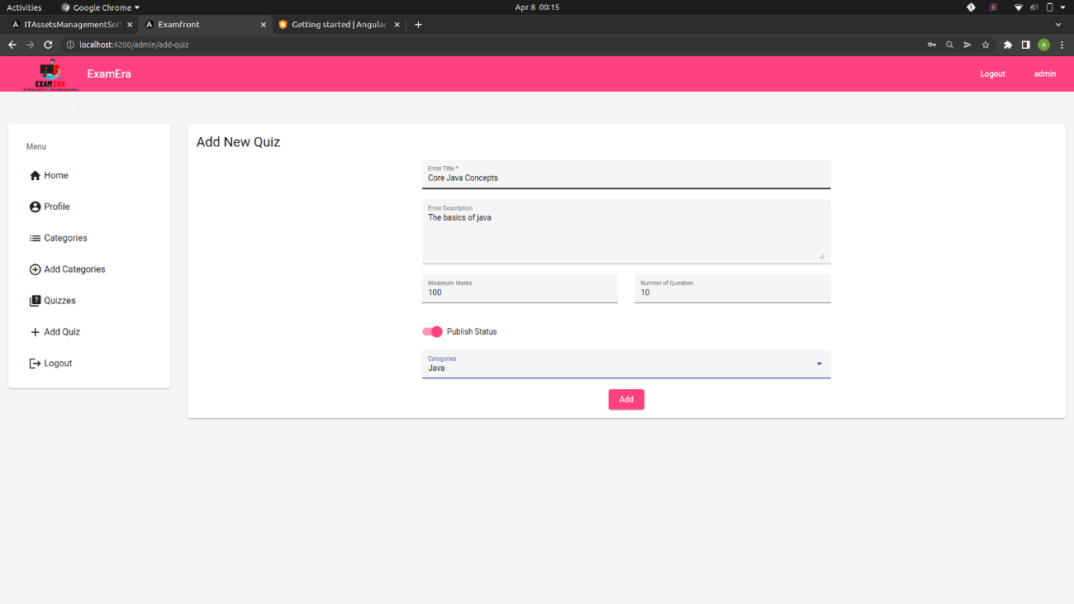

Figure-8.8(Admin Add Quizes)

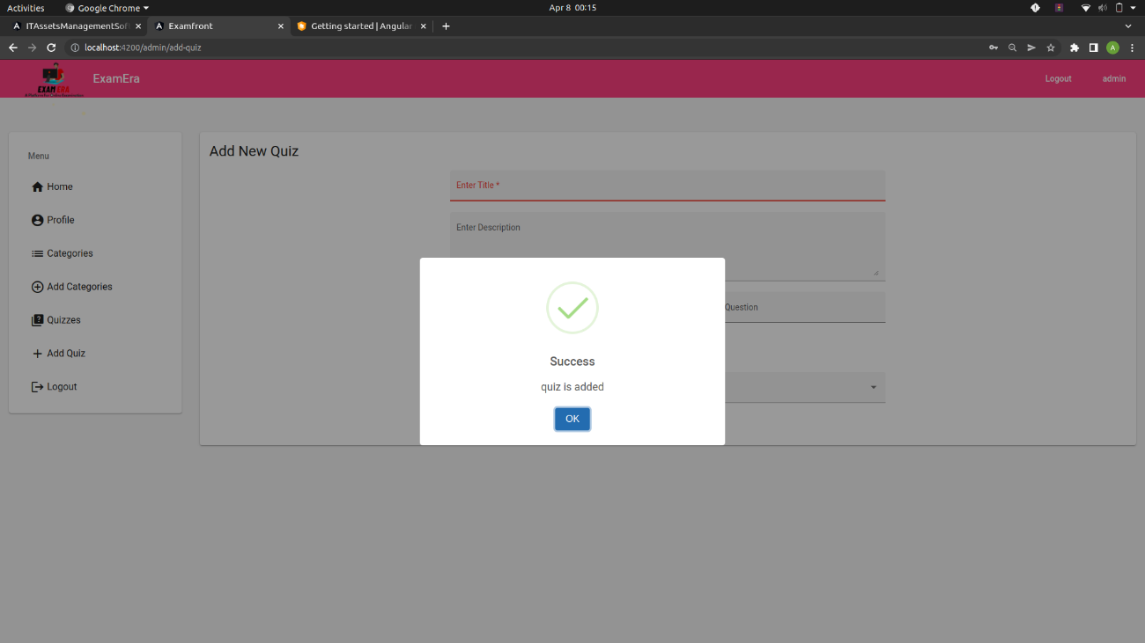

Figure-8.9(Admin Quizes Successful)

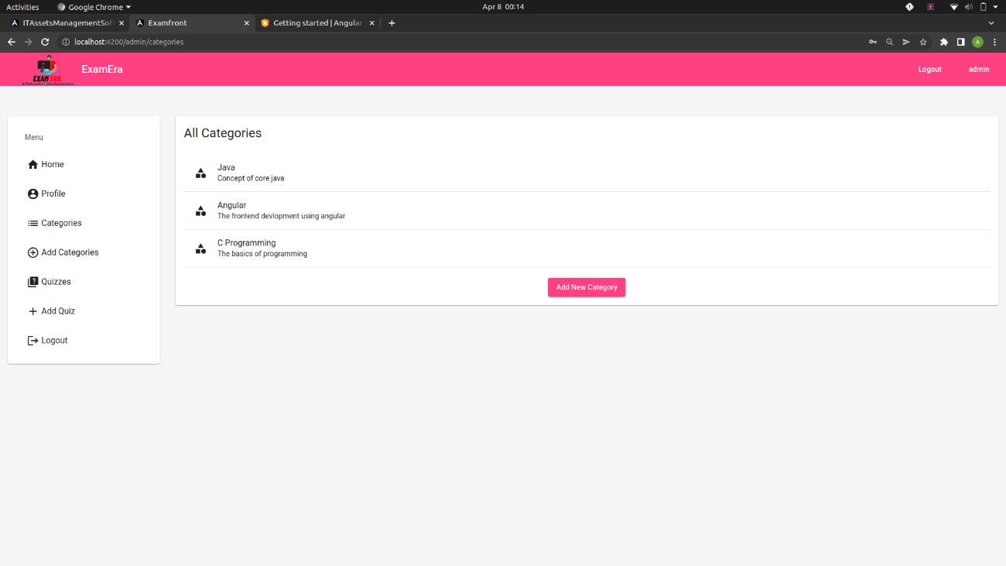

Figure-8.10(Admin All Categories)

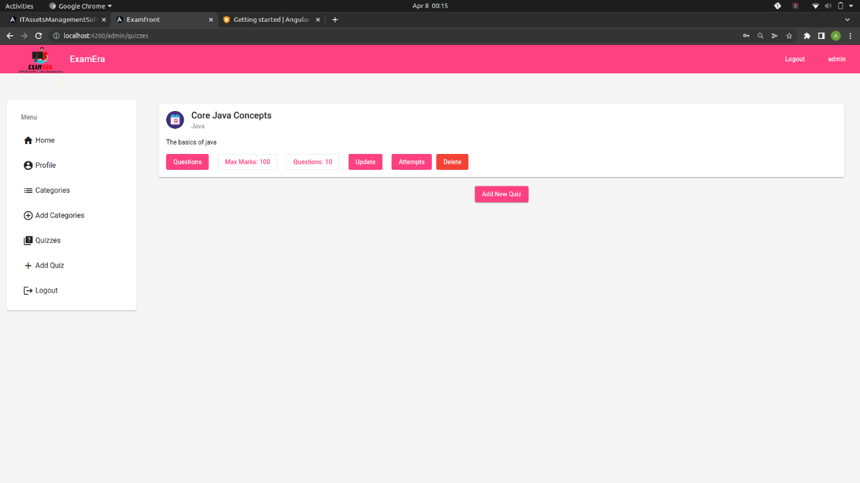

Figure-8.11(Admin All Quizzes)

1. **ADMIN QUESTION PAGE**

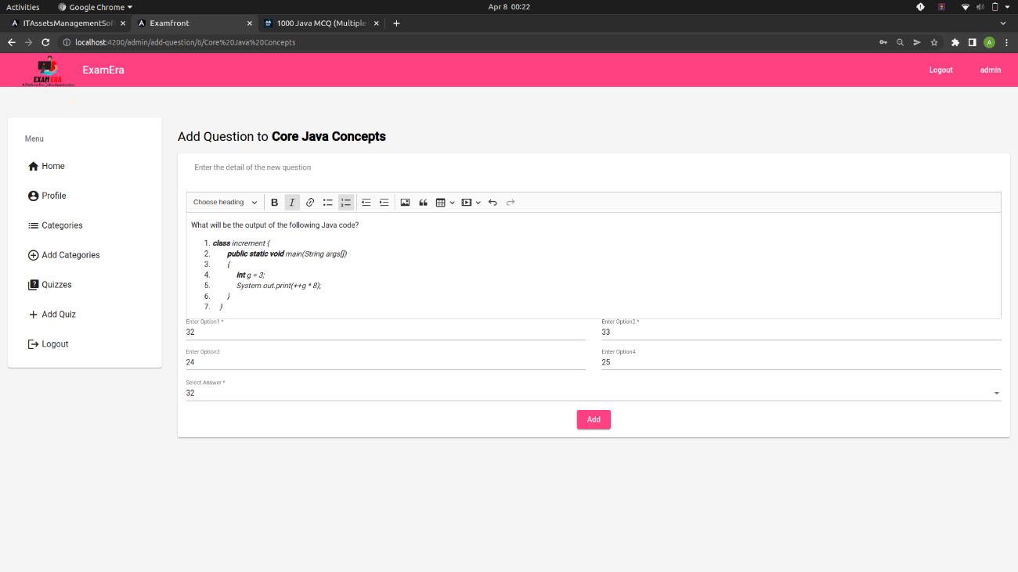

Figure-8.12(Admin Add Questions)

The admin can add the question and all the 4 options of the question, he can also add the correct answer so that the student can immediately check the result after and get to know the correct answer after the successful completion of the exam.

* The Admin can the question in different formats as well (example of the code based question is given in the sample picture above).
* The admin can add the question in a picture mode also.
* The admin can add the question in media and can redirect to another platform through the hyperlink feature also.
* The questions will be well formatted as the indentation is kept in mind for the better understanding for the students.

1. **ADMIN REVIEW PAGE**

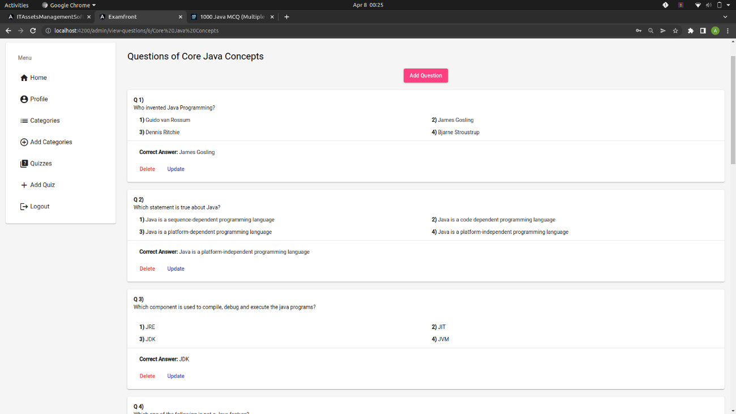

Figure-8.13(Admin review Questions)

The Admin review page is for the admin is to go through the test to check for any correction before the test finally go live for the students.

1. **STUDENT HOME PAGE**

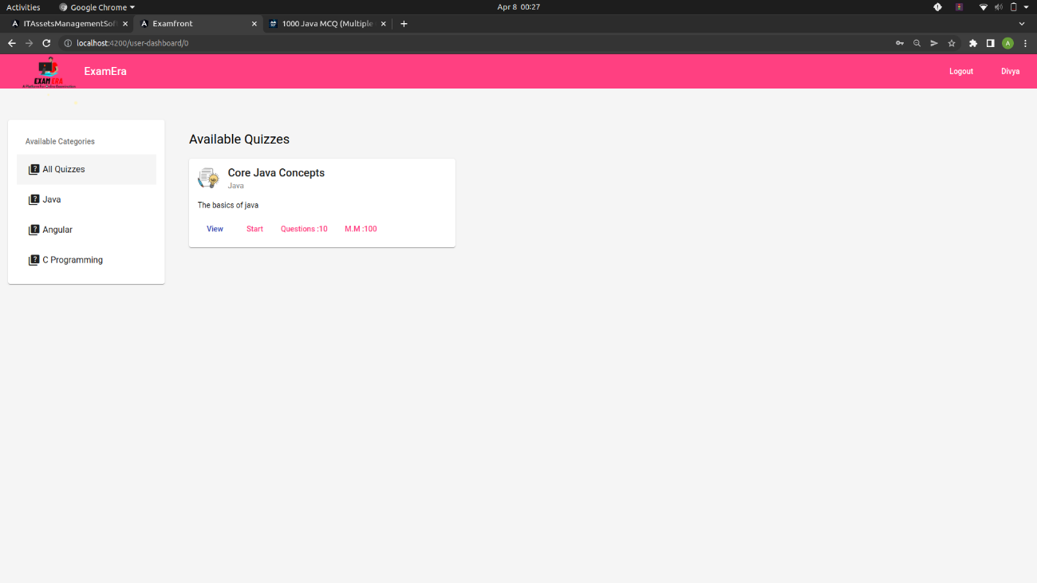

Figure-8.14(Student Home Page)

This is the student home page where the student can check the assigned quizzes.

1. **STUDENT INSTRUCTION PAGE**

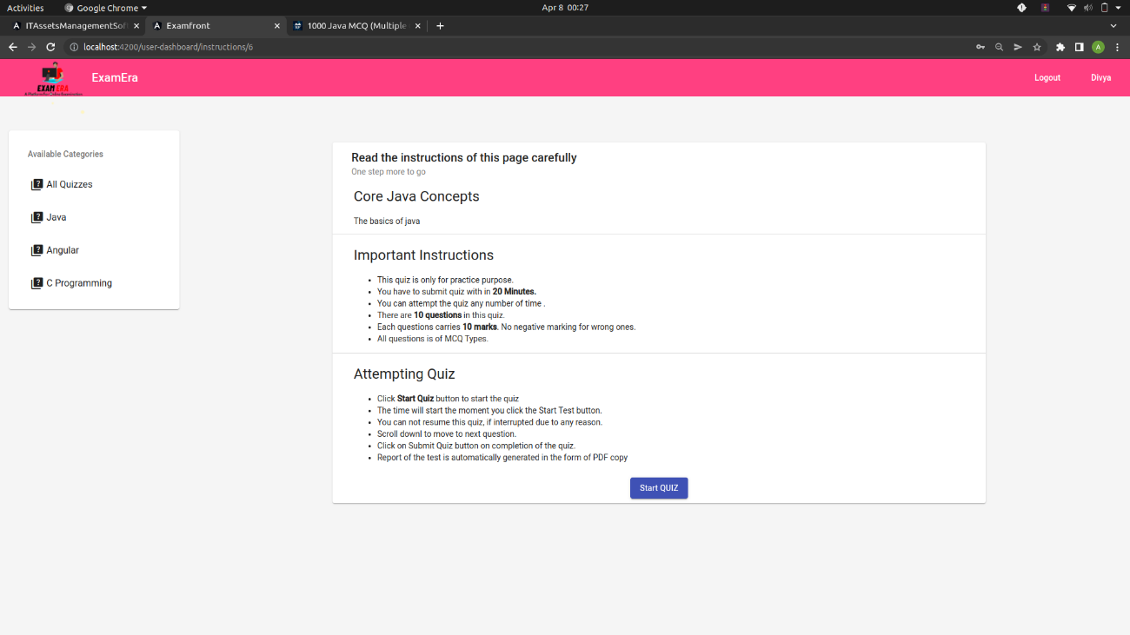

Figure-8.15(Student Instructions Page)

The Student instruction page will comprise of all the important instruction about the platform and nature of the test.It also contain information like the time duration, no of questions, maximum marks and marks per question.

1. **STUDENT TEST PAGE**

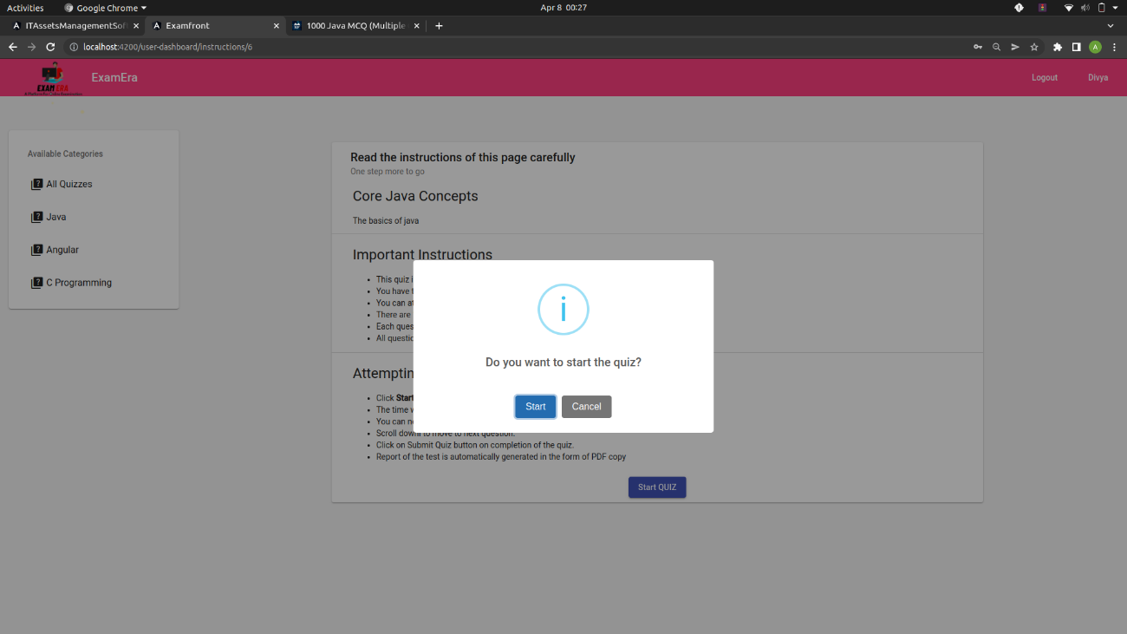

Figure-8.16(Student Before Stating Quiz )

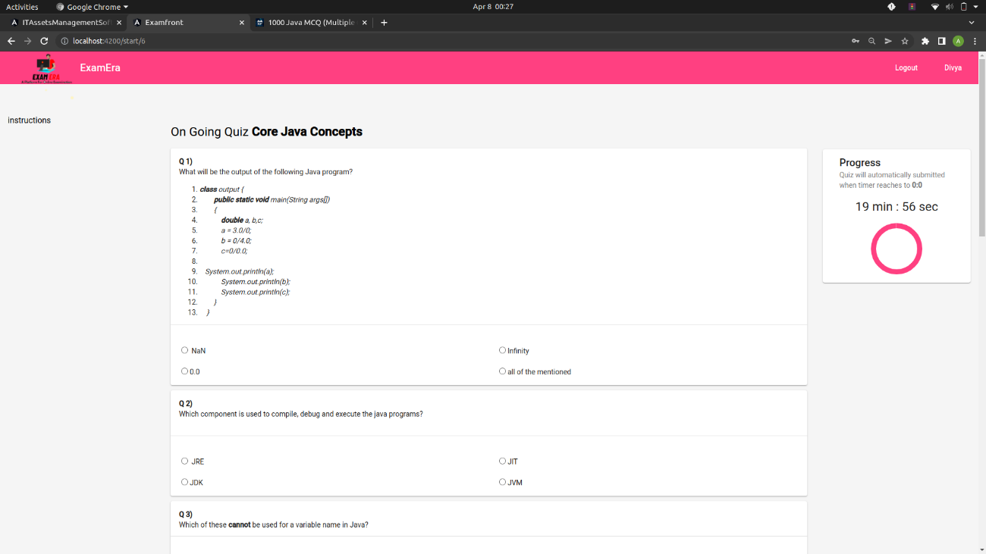

Figure-8.17(Student test screen)

This is the student test screen the questions will appear in a well formatted manner and the timer will be appear on the top right corner.

1. **STUDENT SUBMISSION PAGE**

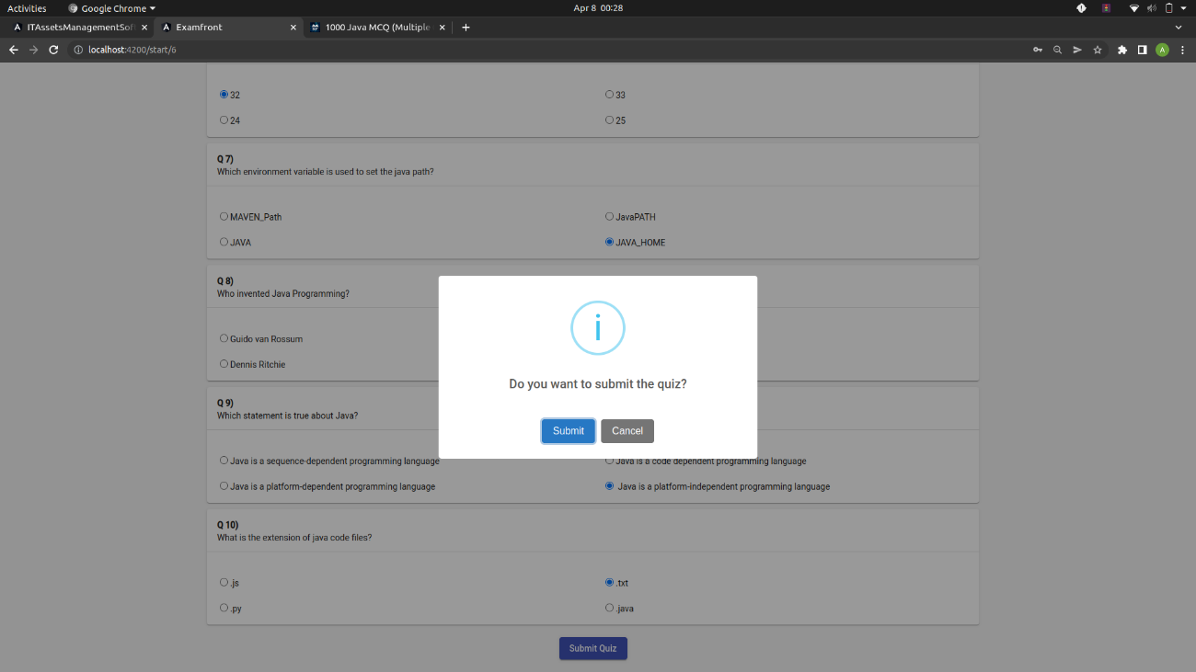

Figure-8.18(Student before submitting quiz)

This is the submission page, a pop-up will come to ensure that the student is willingly submitting the test and it is not due to any disturbance at the student end.

1. **STUDENT RESULT PAGE**

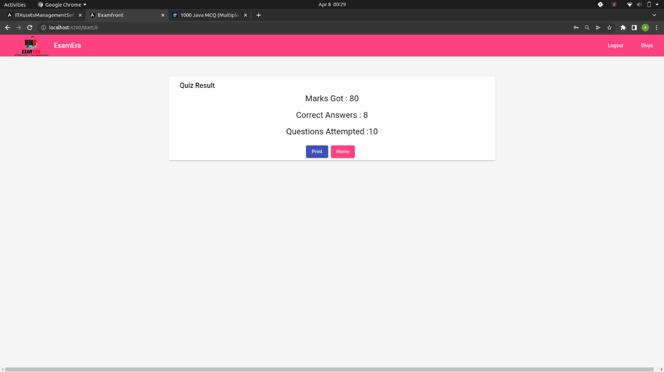

Figure-8.19(Student result screen)

This is the student result page it will immediately appear once the student will submit the test and it will display the information like marks got, questions attempted and no. of the questions given in the test.

1. **ADMIN RESULT PAGE**

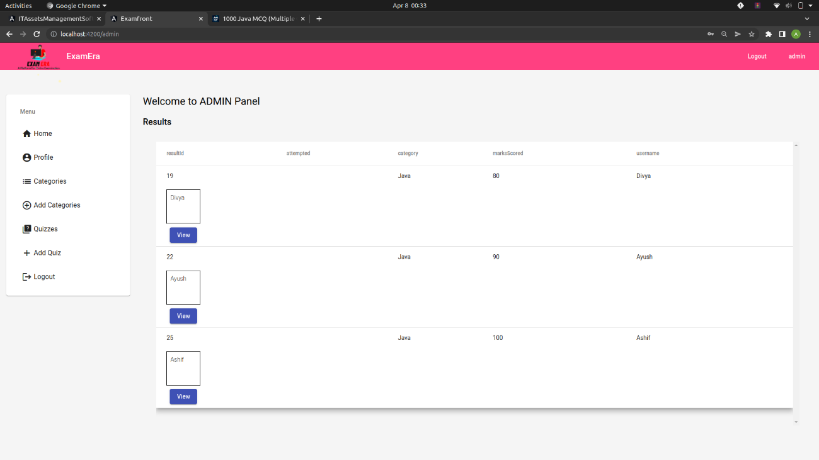

Figure-8.20(Admin Home screen with all result)

This is the admin home screen from where he can see the results of all the student appeared in the examination, he can also check the answer sheet of each student.

**CHAPTER-9**

**CONCLUSION**

It is not enough to focus on the passing required skills to the learners in distance education but to equally furnish them with their performances shortly after evaluation without hitch. Consequently, the developed ExamEra is capable of solving the associated problems with the traditional test methods and equally promotes distance education.

When online method of instruction is used to acquire skills in higher education, the

application can be used for efficient assessments regardless of the location of the

examinees across the globe.

It is possible with this system to space the period of examination without compromising

quality and integrity of the examination. The system has the potentials to reduce

drastically examination malpractice as applicants are duly authenticated online, real-time before taking the examination and the integrity of the result could also be enhanced since the candidates have access to instant result checking.

Hence, in the current era of distance education prompted by the adoption of ICT, the e-

Examination has the advantage of being easy to administer, ability to offer applicants

instant results, easy verification, devoid of paper work and long-time involved in marking examination scripts which in most cases are prone to errors and misplacement of some scripts due to the large volume of scripts that has to be marked and accessed. The system also saves the instructors from sufferings and boring grading of works as well as examinees’ access to results thereby promoting efficient distance education system.

If the e-examination system is fully optimized and it is introduced into the institutions, it

will go a long way to control and check examination malpractices and all fraudulent acts associated with the manual process of writing examination. However, for the system to be adopted on a large scale, efforts should be intensified to ascertain its disadvantage on accounts of IT illiteracy on the part of the students’, by making the interface easy to interact with. Also, to ensure that the e-examination system is not intensified by those that may want to engage in any form of examination malpractice, the addition of user authenticated protocol/methods such as biometrics (fingerprint, retina, iris etc) identification will be of good help.

In future, we intend to address the limitations of the current application by incorporating

online collation of results from various courses examined, compute Cumulative Grade

Point Aggregate(CGPA) and generation of transcripts (with necessary security features) to foster implementation of distance education.

**CHAPTER-10**

**REFRENCES**

1. Ayo, C., Akinyemi, I., Adebiyi, A., & Ekong, U. (2007). The Prospects of E-Examination.
2. Turkish Online Journal of Distance Education-TOJDE, 8(4), 125-134
3. Gardner, L., Sheridan, D., & White, D. (2002). A Web-based learning and assessment
4. system to support flexible education. Journal of Computer Assisted Learning, 18, 125–136.
5. Wang, T. H., Wangw, K. H., W. L. Wangz, Huangz, S. C., & Chen, S. Y. (2004). Web-based
6. Assessment and Test Analyses (WATA). Journal of Computer Assisted Learning, 20, 59-71.
7. Zhenming, Y., Zhang, Z., & Zhan, L. (2003). A novel web-based examination system for computer science education. 33rd ASEE/IEEE Frontiers in Education Conference.
8. C. Xiangjun and W. Fangsheng, “Web-based General Examination System Development”, Proceedings of the 2nd International Conference on Computer Engineering and Technology (ICCET), Chengdu, China , Vol. 3, No. 4, pp. 457-461, April 2010.
9. M. A. Sarrayrih and M. Ilyas, “Challenges of Online Exam, Performances and Problems for Online University Exam”, International Journal of Computer Science Issues (IJCSI), Vol. 10, No. 1, pp. 439-443, January 2013.
10. D. Kochakornjarupong, “Web-based System Design for Enhancing Learning Problem Solving in Artificial Intelligence”, International Journal of the Computer, the Internet and Management (IJCIM), Vol. 18, No. 1, pp. 42.1-42.6, December 2010.
11. J. McGough, J. Mortensen, J. Johnson, and S. Fadali, “A Web-Based Testing System with Dynamic Question Generation”, Proceedings of the ASEE/IEEE International Conference on Frontiers in Education, Renu, Nevada, USA, Vol. 3, pp. 23-28, October 2001.
12. E. Guzman and R. Conejo, “Self-Assessment in a Feasible, Adaptive Web-Based Testing System”, IEEE Transactions on Education, Vol. 48, No. 4, pp. 688-695, November 2005.
13. K. Henke, “Web-Based Test, Examination and Assessment System”, Advanced Technology for Learning, Vol. 4, No. 3, pp. 140-145, June 2007.
14. https://www.javatpoint.com/
15. https://www.tutorialspoint.com/index.htm
16. https://www.geeksforgeeks.org/